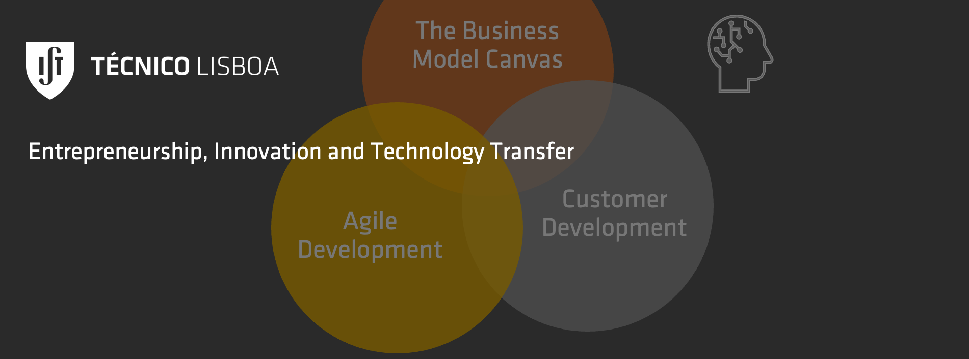

Team Balance

| **Name** | **Roles** | **Function** | **3H** |
| --- | --- | --- | --- |
|  |  | Engineer (Builder)  Designer (Creative)  Marketing (Customers)  Business Planning  Manager | Hacker  Hipster  Hustler |
|  |  | Engineer (Builder)  Designer (Creative)  Marketing (Customers)  Business Planning  Manager | Hacker  Hipster  Hustler |
|  |  | Engineer (Builder)  Designer (Creative)  Marketing (Customers)  Business Planning  Manager | Hacker  Hipster  Hustler |
|  |  | Engineer (Builder)  Designer (Creative)  Marketing (Customers)  Business Planning  Manager | Hacker  Hipster  Hustler |
|  |  | Engineer (Builder)  Designer (Creative)  Marketing (Customers)  Business Planning  Manager | Hacker  Hipster  Hustler |
|  |  | Engineer (Builder)  Designer (Creative)  Marketing (Customers)  Business Planning  Manager | Hacker  Hipster  Hustler |